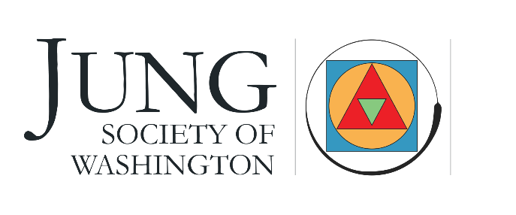
a container for the psyche in an uncertain world

Jung Society Reading Seminar 2022-2023
Year 8: An Advanced Study of Works of Colleagues of Jung
September 2022 - May 2023 (all dates hosted via Zoom)
Date | Time | Presenter | Volume
September 10 | Friday 7-9  Saturday 10-5 | Diane Braden | Friday: Psychic Contagion  Saturday: Edinger, Creation of Consciousness
October 8 | Friday 7-9  Saturday 10-5 | Kathleen Wiley | TBD
November 12 | Saturday | Phyllis LaPlante | Eric Neumann: Depth Psychology and a New Ethic
December 10 |  | TBD | TBD
February 11 | Saturday | James Hollis | Marie Louise von Franz Introduction to Fairy Tales Focus on Iron John,  The Girl with No Hands, and The Blue Light
March 11 | Saturday | Julie Bondanza | Edinger,  Anatomy of Psyche
April 8 | Saturday | Anne Pickup | Animals: Neal Rusack, Barbarah Hannah, James Hillman
May 13 |  | TBD | TBD

