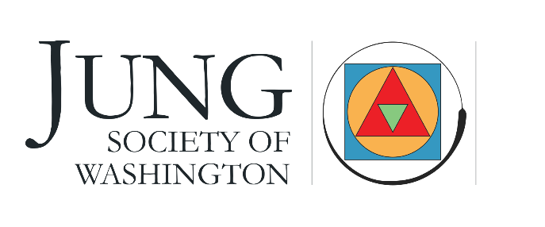
a container for the psyche in an uncertain world

Jung Society Reading Seminar 2021-2022
Year 7: An Advanced Study of Carl Jung’s Collected Works
September 2021 - May 2022 (all dates hosted via Zoom)
Date | Time | Presenter | Volume Collected Works (CW)
September 11 | Saturday 10-5 pm | Jane Selinske | CW 9: P1
October 8-9 | Friday 7-9 | Mark Dean | CW 8
 | Saturday 10-3
November 13 | 10-5 pm | Robert Bump | CW 11, West
December 10-11 | Friday 10-5 | James Hollis | CW 5
February 12 | Saturday 10-5 | Royce Froelich—Psychology and Religion | CW 11 (East) & 13 and maybe the ETH lectures on Yoga and Meditation
March 11, 12, 13? | TBD | TBD | TBD
April 9 | Saturday 10-5 | Janis Maxwell | CW 10
May 13 | Friday 10-5 pm | Julie Bondanza | CW 16

